AWS SQS (Simple Queue Service)

Amazon SQS is a fully managed message queue service from Amazon Web Services used for decoupling applications and asynchronous communication.
It allows applications/components to communicate through messages without being directly connected.

🚀 Why We Use SQS
SQS helps:
- Reduce dependency between services
- Improve scalability
- Prevent application overload
- Process tasks asynchronously

⚙️ How SQS Works
Producer → SQS Queue → Consumer
Example:
- Web app uploads image
- Message sent to SQS
- Worker processes image later

📌 Types of SQS Queues
Queue Type | Description
Standard Queue | High throughput, at-least-once delivery
FIFO Queue | First-In-First-Out, exactly-once processing

🔥 Common Use Cases
- Background job processing
- Order processing systems
- Email notification systems
- Microservices communication
- Buffering traffic spikes
Create SQS QueueStandard or FIFOSend Message to QueueEnter message &sendReceive Message
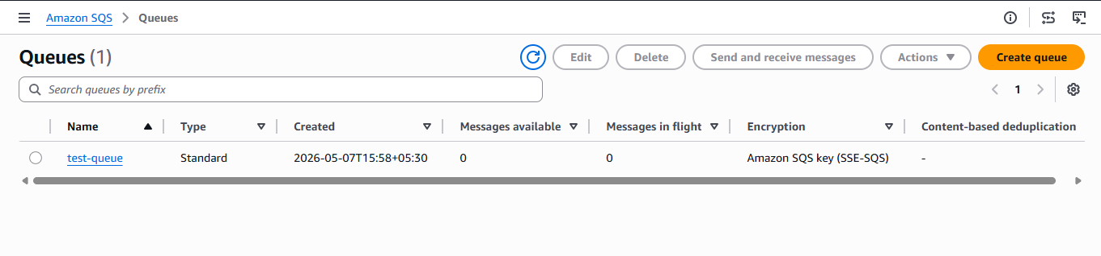

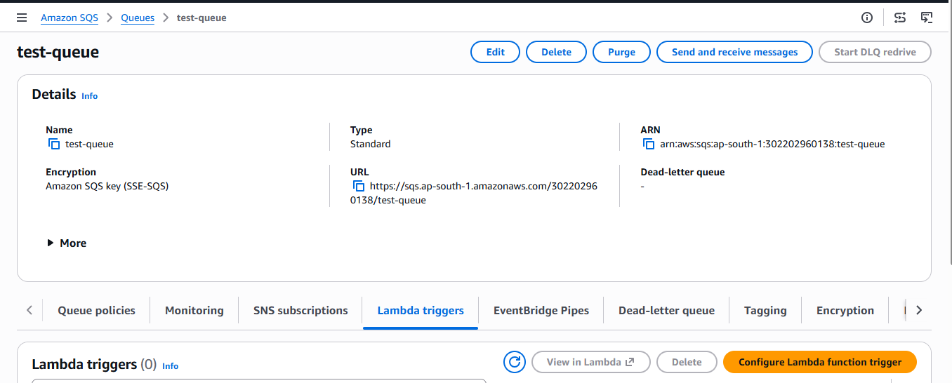
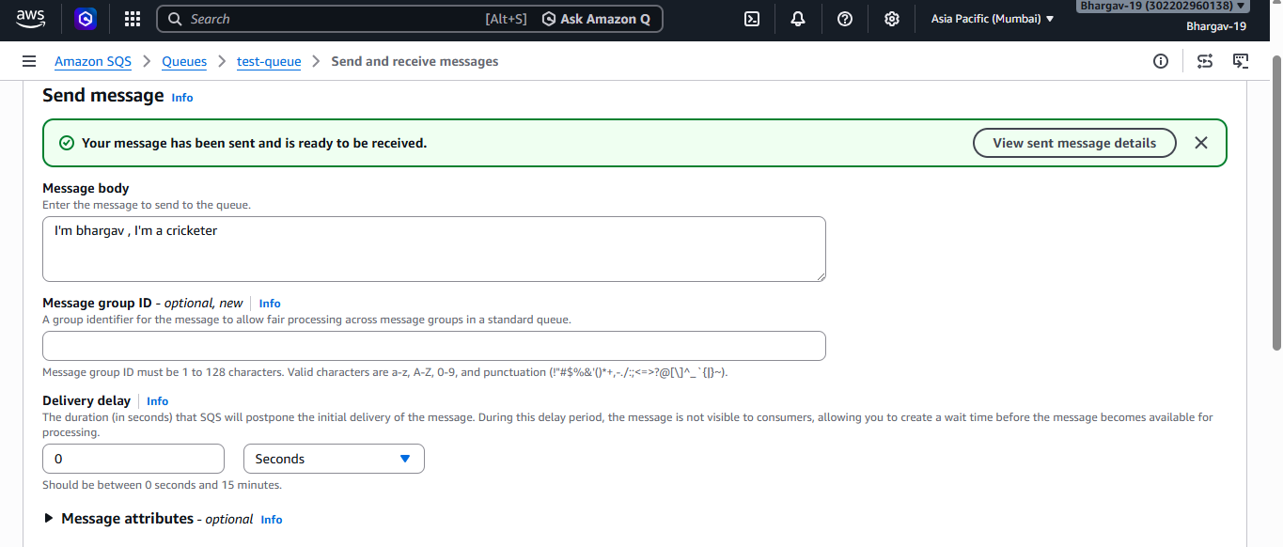

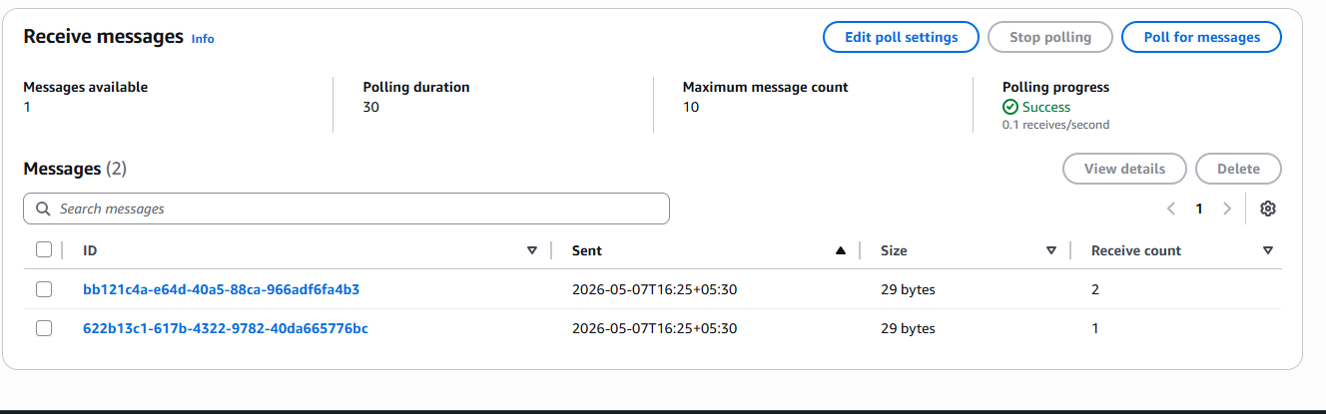

AWS Amazon MQ
Amazon MQ is a managed message broker service from Amazon Web Services that supports:
- ActiveMQ
- RabbitMQ
It is mainly used for legacy or enterprise applications that require standard messaging protocols.

🚀 Why Use Amazon MQ
Use Amazon MQ when applications require:
- JMS
- AMQP
- MQTT
- STOMP
- Open Wire
These protocols are not supported directly by SQS.

⚙️ How Amazon MQ Works
Producer ↔ Amazon MQ Broker ↔ Consumer
Unlike SQS, clients maintain direct broker connections.

🔥 Common Use Cases
- Enterprise integrations
- Legacy application migration
- Banking systems
- Financial messaging
- IoT communication

📌 Amazon MQ vs SQS
Feature | SQS | Amazon MQ
Fully Serverless | Yes | No
Message Broker | No | Yes
Protocol Support | AWS-native | JMS, AMQP, MQTT
Scalability | Very high | Moderate
Maintenance | Minimal | More management
Best For | Cloud-native apps | Legacy enterprise apps

Create Amazon MQ BrokerCreate BrokerBroker name & Username/passwordClick Create broker.

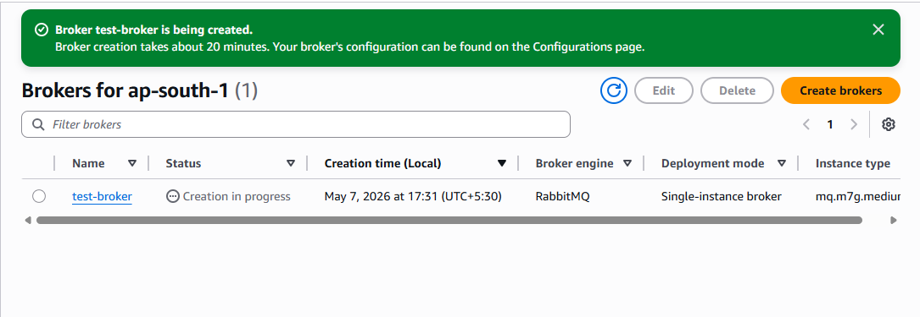

Click on URL redirected to RabbitMQ site in browser
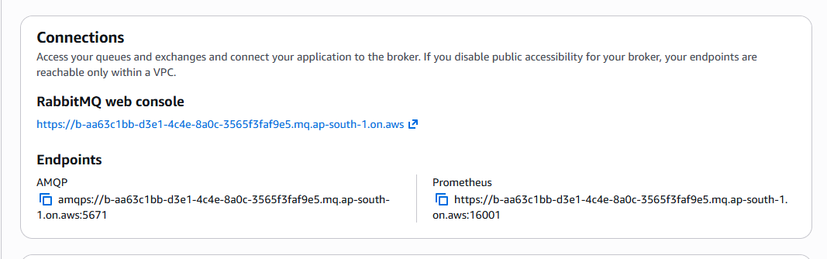
Click on queues and streamsadd queuepublish massages click on get messages
